Pf assignment 1:
Name : Alveena Naz
Registration number : FA25 -BSE-010

Question 1: (Part a)
!st Statement:
public class FirstJava
{
public static void main(String[] args)
{
System.out.println(" Welcome to java")
}
}
Error Name
‘;’ expected
At the end of every statement there is need of a terminator.
2nd Statement:
public class FirstJava
{
public static void main(String[] args)
{
int number = 2.14;
System.out.println( number) ;
}
}
Error name:
Incompatible type: possible lossy conversion from double to int.
We cannot add double type into integer variable.
3rd Statement:
public class FirstJava
{
public static void main(String[] args)
{
Count+=1;
System.out.println(number);
}
}
Error Name:
cannot find symbol symbol: variable count.
Any variable should be written with its data type.

Part (b);
Statement 1:
import java.util.Scanner;
public class FirstJava
{
public static void main(String[] args)
{
int a = 2, b = 3;
int sum = a – b;
System.out.println(sum);
}
}
The programmer wanted addition but wrote subtraction. So, the output will be change.
Statement 2:
import java.util.Scanner;
public class FirstJava
{
public static void main(String[] args)
{
int a = 2 , b = 3 , c = 5;
int average = a + b + c/2;

System.out.println(average);
}
}
In this, the numbers should divide by 3 to get exact value of average.
Statement 3:
import java.util.Scanner;
public class FirstJava
{
public static void main(String[] args)
{
int num = 4;
if( num%2 == 1)
System.out.println(" even number");
else
System.out.println(" odd number");
}
}
In if statement , there should be 1 in condition . Now the given output will be odd number which wrong.

Part (c);
import java.util.Scanner;
public class FirstJava
{
public static void main(String[] args)
{
double num = -16;
double result = Math.sqrt(num);
System.out.println(result);
}
}
Output will be “NAN” because the square root of negative number is not defined in a real numbers.
Statement 2:
import java.util.Scanner;
public class FirstJava
{
public static void main(String[] args)
{
int big = 2147483647;
int result = big + 1;
System.out.println(result);
}
}
Output will be in negative number because integer size exceeds.
Statement 3:
public class FirstJava
{
public static void main(String[] args)
{
int a = 25;
int b = 0;
int result = a / b;
System.out.println(result);
}
}
java.lang.ArithmeticException: / by zero
For integers divide by zero is undefined in java.

Part (d):
Code error | Type of error | Correction
count = 1; | Syntax error | Int count = 1;
Sum = count + PRIME; | Syntax error | Int PRIME= 4;  Int sum = count +PRIME;
x := 25.67; | Syntax error | Double x = 25.67
newNum = count * ONE+ 2; | Syntax error | Int ONE = 1;  Int newNum = count * ONE + 2;
sum + count = sum; | Syntax error | sum = sum + count;
System.out.println(" count = " + count + ", sum = " + sum + ", PRIME = " + Prime); | Syntax error  Replace Prime with PRIME | System.out.println(" count = " + count + " ,sum = " + sum + ", PRIME = " +PRIME);

public class FirstJava
{
public static void main(String[] args)
{
int count = 1;
final int PRIME = 7;
final int ONE = 1;
double x = 25.67;
int sum = count + PRIME;
int newNum = count * ONE + 2;

x = x + sum * count;
System.out.println("count = " + count + ", sum = " + sum + ", PRIME = " + PRIME);
}
}
OUTPUT:
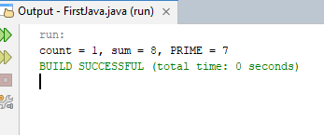

Question 2:
Comments  Single line comment  Multiple line comments | /*This program will calculate product of three numbers */  int num1 = 10; // first number  int num2 = 20; // second number  int num3 = 1; // third number;
Special symbols | {}, (), ;
Reserve words | public , class , main
Identifiers predefined  defined by user | System, println,out  num1, result, product
Standard input stream object | System.in
Standard output stream object | System.out

Question 3 :

Part(a):
public class FirstJava
{
public static void main(String[] args)
{
int x , y;
x = 10;
char ch = 'B';
x+=5;
double payRate = 12.50;
int firstNum = 12;
int tempNum = firstNum;
y = 5;
int temp = x;
x = y;
y = temp;
double dx = 12.5;
double dy = 7.8;
System.out.println(" x = " + x + " y = " + y + " x + 12/ y - 18 = " + (x + 12/ y -18));
char grade = 'A';
int n1, n2, n3 , n4;
double z = 5.675;
int newx = (int)Math.round(z);
}
}

Part(b);
Statements | a | b | c | d
a = (b++) + 3 * ++d; | 15 | 7 | UND | 3
c = 2 * d + (++b) + a; | 5 | 7 | 16 | 2
b = 2 * (++c) - (a++); | 5 | 29 | 17 | 2
d = d++ + d + b++ + b; | 5 | 7 | 17 | 18

Part (c);
Statements | a | b | c | sum
sum = a + b + ( int) c; | 3 | 5 | 14 | 22
c /= a; | 3 | 5 | 4.7 | UND
b += (int) c - a; | 3 | 16 | 14.1 | UND
a *= 2 * b + (int) c; | 72 | 5 | 14.1 | UND

Question 4:
import java.util.Scanner;
public class FirstJava
{
public static void main(String[] args)
{
Scanner input = new Scanner( System.in);
System.out.println(" Enter the value of a :");
double a = input.nextDouble();
System.out.println(" Enter the value of b :");
double b = input.nextDouble();
System.out.println(" Enter the value of c :");
double c = input.nextDouble();

double disc = b * b - 4 * a * c;
if( disc > 0)
{
double r1 = (-b + Math.pow(disc, 0.5)) / (2 * a);
double r2 = (-b - Math.pow(disc, 0.5)) / (2* a);
System.out.println(" The equation has two real solution :" + r1 + "and" + r2);
}
else if(disc == 0)
{
double r1 = (-b + Math.pow(disc, 0.5)) / (2 * a);
System.out.println(" The equation has one real solution :" + r1);
}
else
{
System.out.println(" The equation has no real solution :");
}
}
}
OUTPUT:
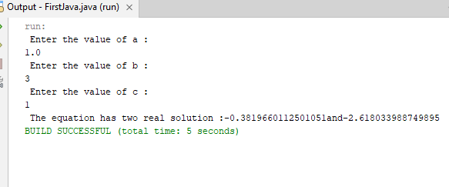

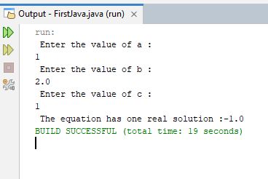

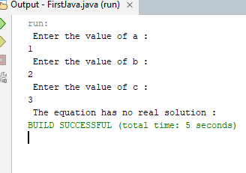

Question 5:
import java.util.Scanner;
public class FirstJava
{
public static void main(String[] args)
{
Scanner input = new Scanner( System.in);
System.out.println(" Enter a random number between 1 and 12");
int month = input.nextInt();
switch( month)
{
case 1: System.out.println(" January");
break;
case 2: System.out.println(" February");
break;
case 3: System.out.println(" March");
break;
case 4: System.out.println(" April");
break;
case 5: System.out.println(" May");
break;
case 6: System.out.println(" June");
break;
case 7: System.out.println(" July");
break;
case 8: System.out.println(" August");
break;
case 9: System.out.println(" September");
break;
case 10: System.out.println(" October");
break;
case 11: System.out.println("November");
break;
case 12: System.out.println(" December");
defalut: System.out.println(" Invalid Number ");
}

}
}
OUTPUT:

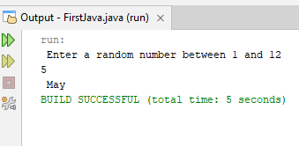

Question 6:
import java.util.Scanner;
public class FirstJava
{
public static void main(String[] args)
{
Scanner input = new Scanner( System.in);
System.out.println(" Enter a number for today's day between 0 and 6:");
int today = input.nextInt();
System.out.println(" Enter the number of days elapsed since today :");
int elapseDay = input.nextInt();
int futureDay =( today + elapseDay) % 7;
// Display today’s day
switch(today)
{
case 0: System.out.println(" Today is Sunday ");
case 1: System.out.println(" Today is Monday ");
break;
case 2: System.out.println(" Today is Tuesday ");
break;
case 3: System.out.println(" Today is Wednesday ");
break;
case 4: System.out.println(" Today is Thursday ");
break;
case 5: System.out.println("Today is Friday ");
break;
case 6: System.out.println(" Today is Saturday ");
break;
default: System.out.println(" Invalid number");
}
// Display futureDay
switch(futureDay)
{
case 0: System.out.println("and the future day is Sunday ");
case 1: System.out.println("and the future day is Monday ");
break;
case 2: System.out.println("and the future day is Tuesday ");
break;
case 3: System.out.println("and the future day is Wednesday ");
break;
case 4: System.out.println("and the future day is Thursday ");
break;
case 5: System.out.println("and the future day is Friday ");
break;
case 6: System.out.println("and the future day is Saturday ");
break;
}

}
}

OUTPUT:
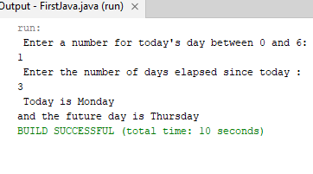
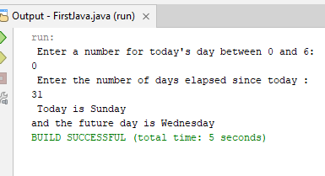

Question 7:
import java.util.Scanner;
public class FirstJava
{
public static void main(String[] args)
{
Scanner input = new Scanner( System.in);
System.out.println(" Enter 1st numbers ");
int num1 = input.nextInt();
System.out.println(" Enter 2nd numbers ");
int num2 = input.nextInt();
System.out.println(" Enter 3rd numbers ");
int num3 = input.nextInt();

int temp;
if(num1 > num2)
{
temp = num1;
num1 = num2;
num2 = temp;

}
if(num2 > num3)
{
temp = num2;
num2 = num3;
num3 = temp;
}
System.out.println(num1 + " "+ num2 + " "+ num3);

}
}
OUTPUT:
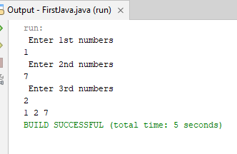

Question 8:

import java.util.Scanner;
public class FirstJava
{
public static void main(String[] argd)
{
Scanner input = new Scanner(System.in);
System.out.println(" Enter the first 9 digits of an ISBN as integer:");
int number = input.nextInt();
int d1 = number / 100000000;
int d2 = (number / 10000000) % 10;
int d3 = (number / 1000000) % 10;
int d4 = (number / 100000) % 10;
int d5 = (number / 10000) % 10;
int d6 = (number / 1000) % 10;
int d7 = (number / 100) % 10;
int d8 = (number / 10) % 10;
int d9 = number % 10;

int d10 = ( d1 * 1 + d2 * 2 + d3 * 3 + d4 * 4 + d5 * 5 + d6 * 6 + d7 * 7 + d8 * 8 + d9 * 9) % 11;

if( d10 == 10)
System.out.println( d1+ "" + d2+"" + d3+ ""+ d4+ "" + d5+ "" + d6+ "" + d7+"" +d8 +"" + d9+ ""+ " X");
else
System.out.println( d1+ "" + d2+"" + d3+ ""+ d4+ "" + d5+ "" + d6+ "" + d7+"" +d8 +"" + d9+ ""+d10);

}
}

Output:
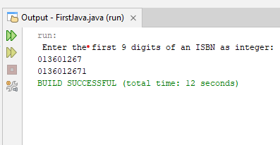

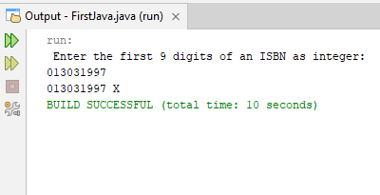

Question 9:
import java.util.Scanner;
public class FirstJava
{
public static void main(String[] args)
{
Scanner input = new Scanner( System.in);
System.out.println(" Enter a three digit integer: ");
int number = input.nextInt();

int lastDigit = number % 10;
int firstDigit = number / 100;

if(firstDigit == lastDigit)
System.out.println(number + " is a palindrome");
else
System.out.println(number + " is not a palindrome");

}
}
OUTPUT:
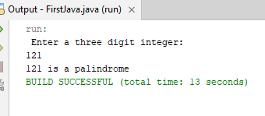
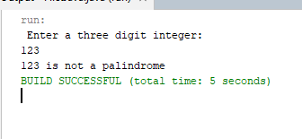

Question 10:
import java.util.Scanner;
public class FirstJava
{
public static void main(String[] args)
{
Scanner input = new Scanner( System.in);
System.out.println(" Guess a toss by choosing 0 for head and 1 for tail: ");
int guess = input.nextInt();
int coinFlip = (int)(Math.random() * 2);

if(guess == coinFlip)
System.out.println(" Your guess is correct");
else
System.out.println(" sorry, your guess is incorrect");

}
}
OUTPUT:
